i-Finance UAT Results — Freelancers (App 203)
Automated UAT run · 12-Jun-2026 · Environment: http://localhost:8080 (dev-proxy → ADB PROD)
Executed by Claude (Playwright). Mirrors UAT_FL_12-Jun-2026-NN.xlsx — one section per workbook case, with the evidence screenshot captured at the verification moment. Personas: SYS_ADMIN, FL_ADMIN (AYESHA.AMERI), FL_MANAGER (NASER.ALKHAJA), FL_USER (SHAIKHA.GALAMERI). Lifecycle cases used fresh UAT-created records; seeded workbook samples were preserved where possible.

Summary
35 cases — PASS: 34 PARTIAL: 1
Area | Cases | Pass | Partial/Manual | Fail | Pass %
Access & Session | 3 | 3 | 0 | 0 | 100%
Dashboard | 2 | 2 | 0 | 0 | 100%
Registrations | 5 | 5 | 0 | 0 | 100%
Freelancers | 5 | 5 | 0 | 0 | 100%
Contracts | 7 | 7 | 0 | 0 | 100%
Payments | 5 | 5 | 0 | 0 | 100%
Compliance | 2 | 1 | 1 | 0 | 50%
Approvals | 3 | 3 | 0 | 0 | 100%
Administration | 1 | 1 | 0 | 0 | 100%
Shell & Language | 2 | 2 | 0 | 0 | 100%

Access & Session

FL-ACC-01 — Entry from Admin
PASS · Shared session · 12s
Admin login → module switcher → FL opened logged-in, full SYS_ADMIN nav
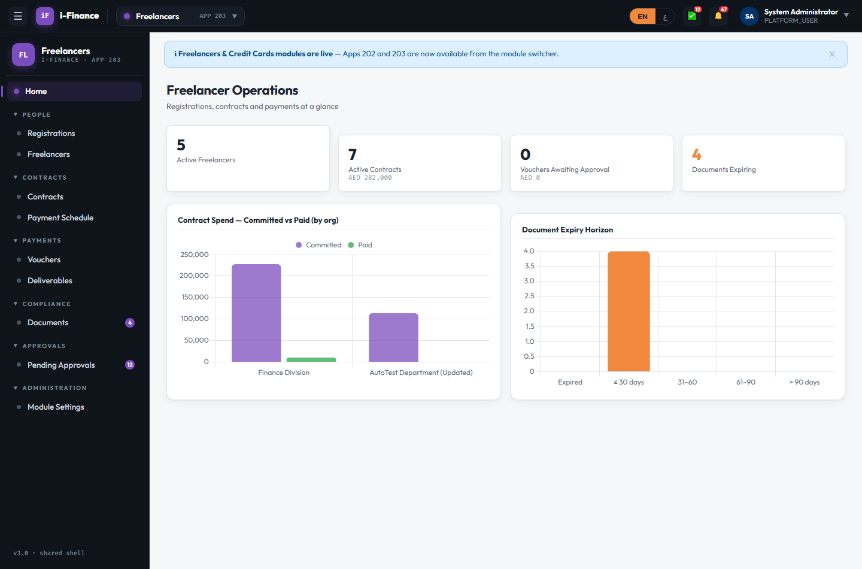
Evidence: FL-ACC-01.png

FL-ACC-02 — Direct open without login
PASS · No session · 8s
FL without a session redirected to the Admin portal login
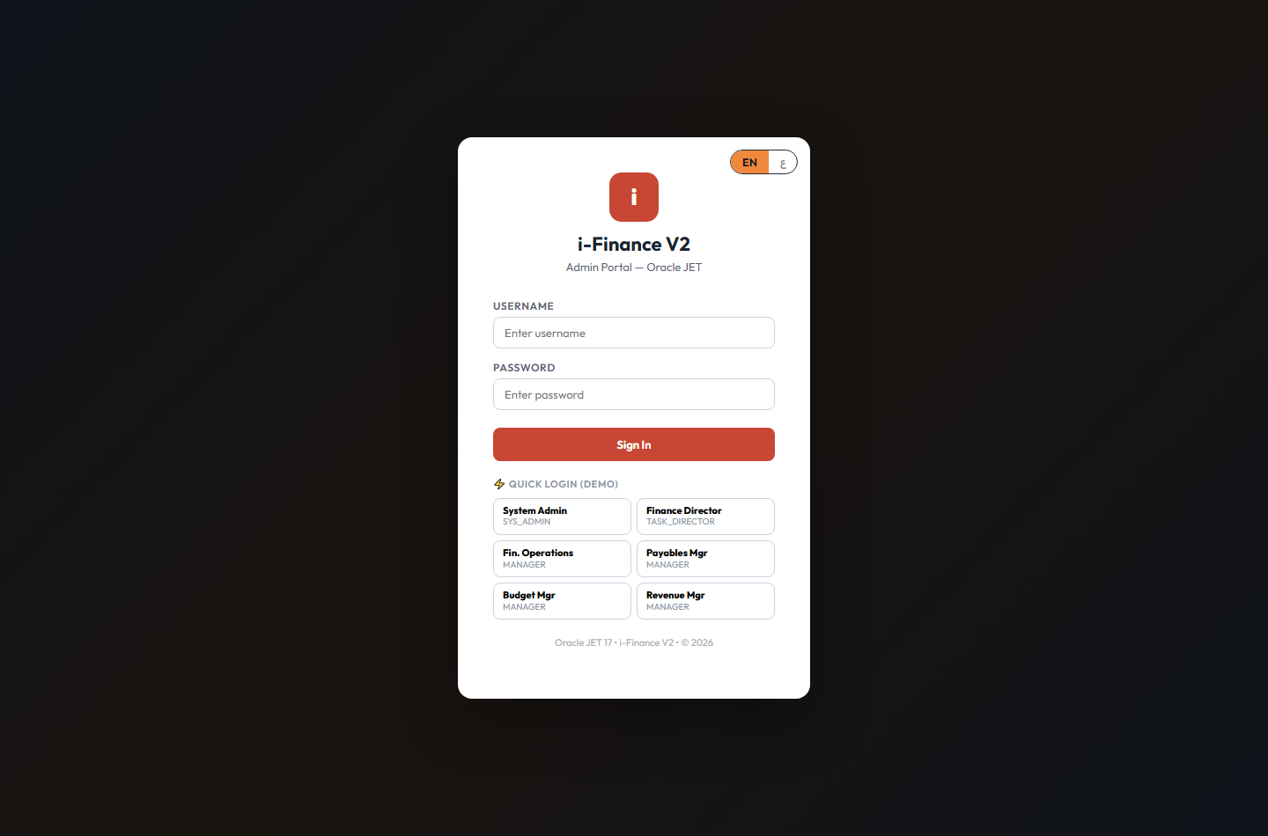
Evidence: FL-ACC-02.png

FL-ACC-03 — Compliance/Approvals/Admin menus
PASS · Role gating · 19s
Nav gating correct: officer < manager (+Compliance/Approvals) < admin (+Module Settings)
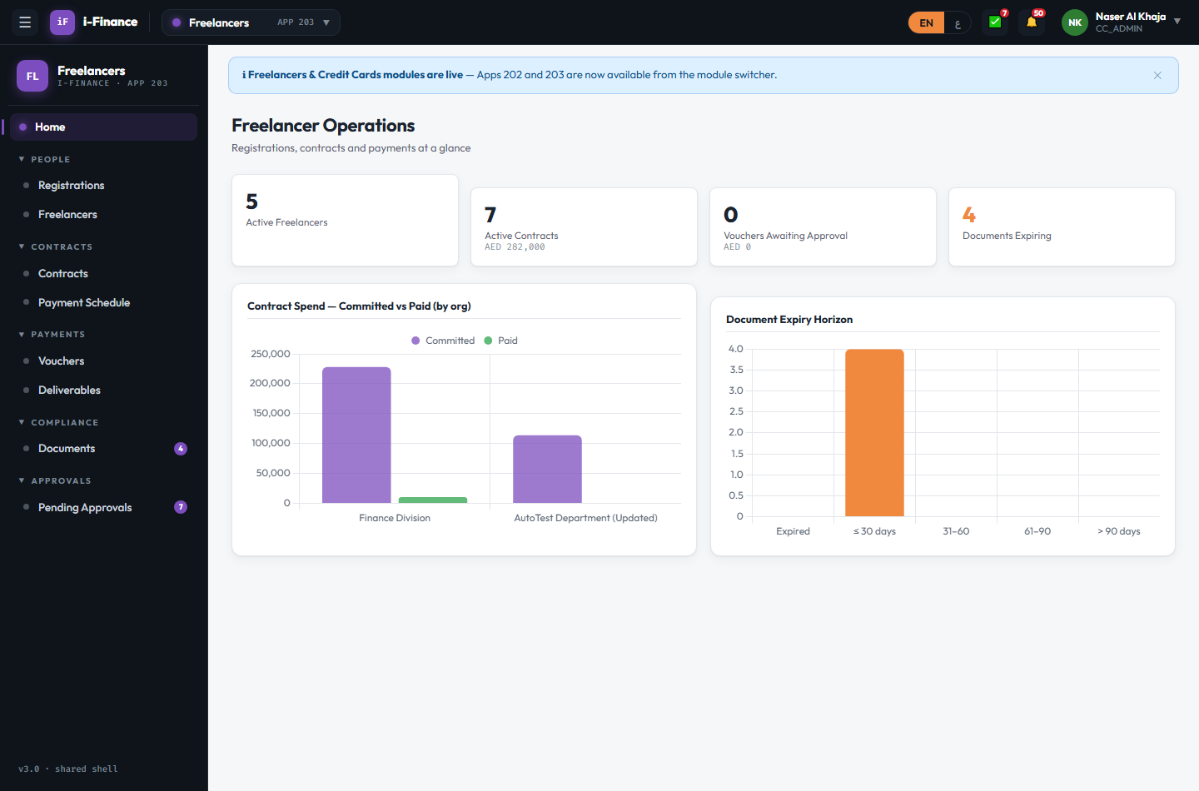
Evidence: FL-ACC-03.png

Dashboard

FL-DSH-01 — Cards show live numbers
PASS · Stats · 4s
Stat cards live: 5, 7, 0, 4
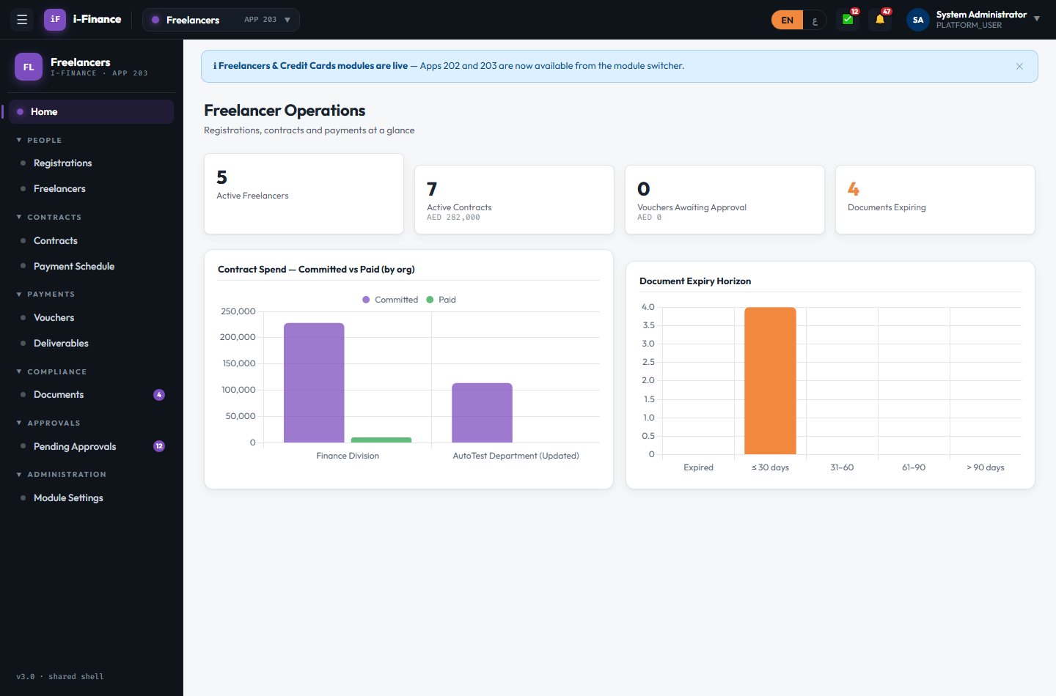
Evidence: FL-DSH-01.png

FL-DSH-02 — Spend + expiry horizon
PASS · Charts · 5s
Committed-vs-paid + document expiry horizon charts rendered (2 canvases)

Evidence: FL-DSH-02.png

Registrations

FL-REG-01 — Paged list + search
PASS · List · 9s
29 rows; search "Omar" matched 1; DRAFT filter → 2 rows; FL-REG numbers shown
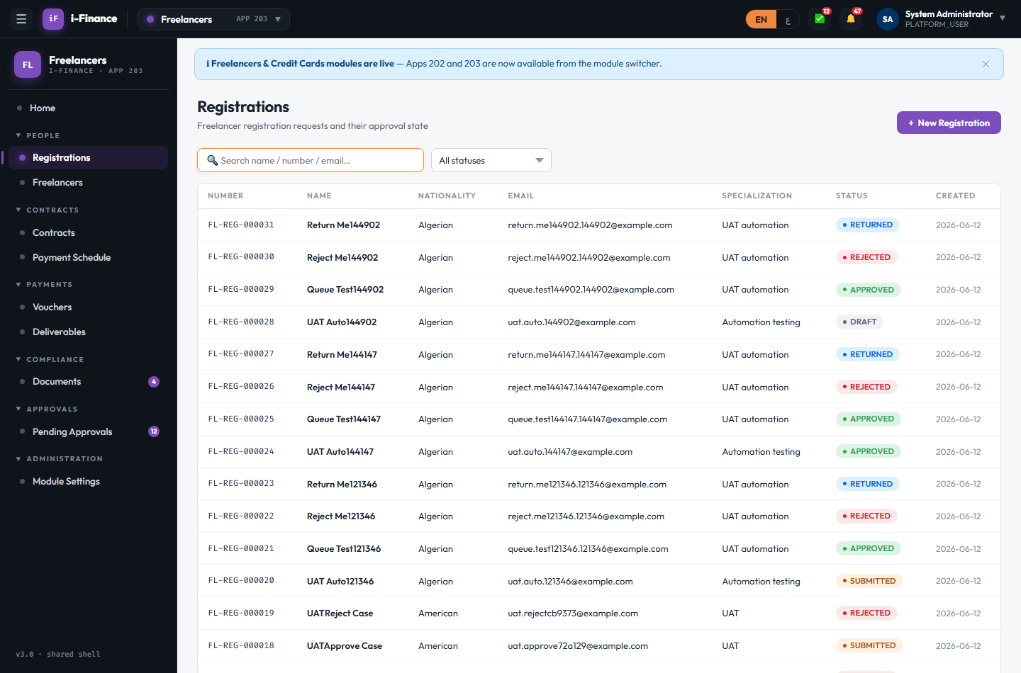
Evidence: FL-REG-01.png

FL-REG-02 — New registration draft
PASS · Create · 8s
Draft FL-REG-000032 saved; appears as DRAFT
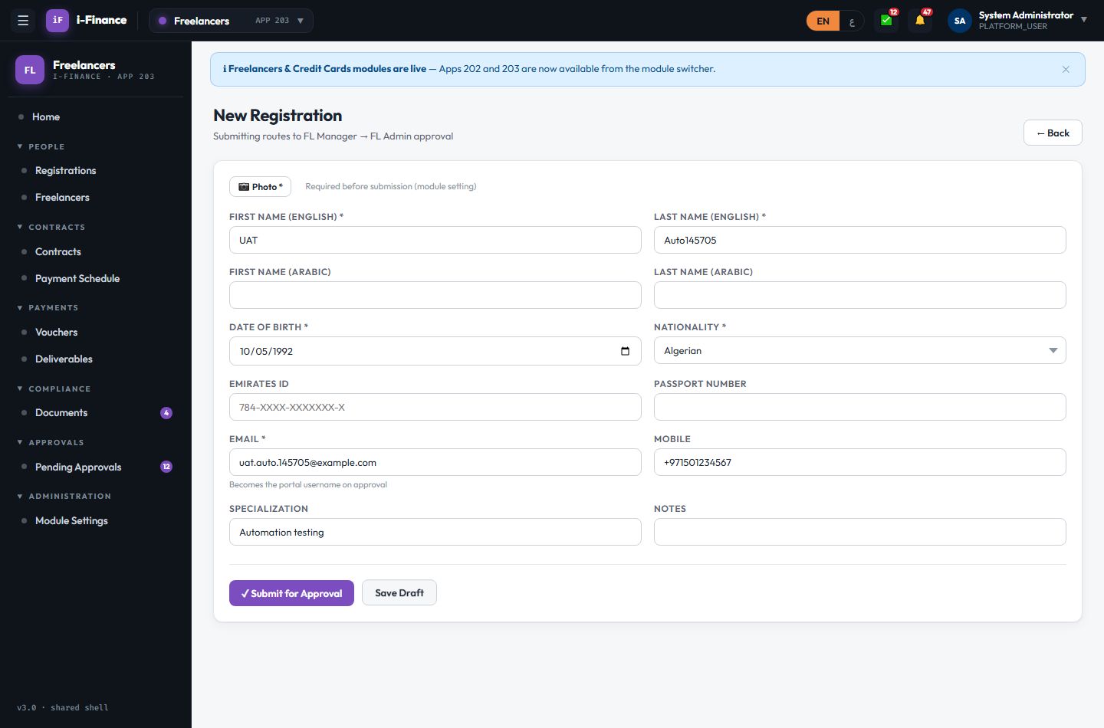
Evidence: FL-REG-02.png

FL-REG-03 — Photo required to submit
PASS · Photo · 7s
Submit blocked without photo ("⚠
ORA-20132: A photo is required before submission."); photo then uploaded and stored
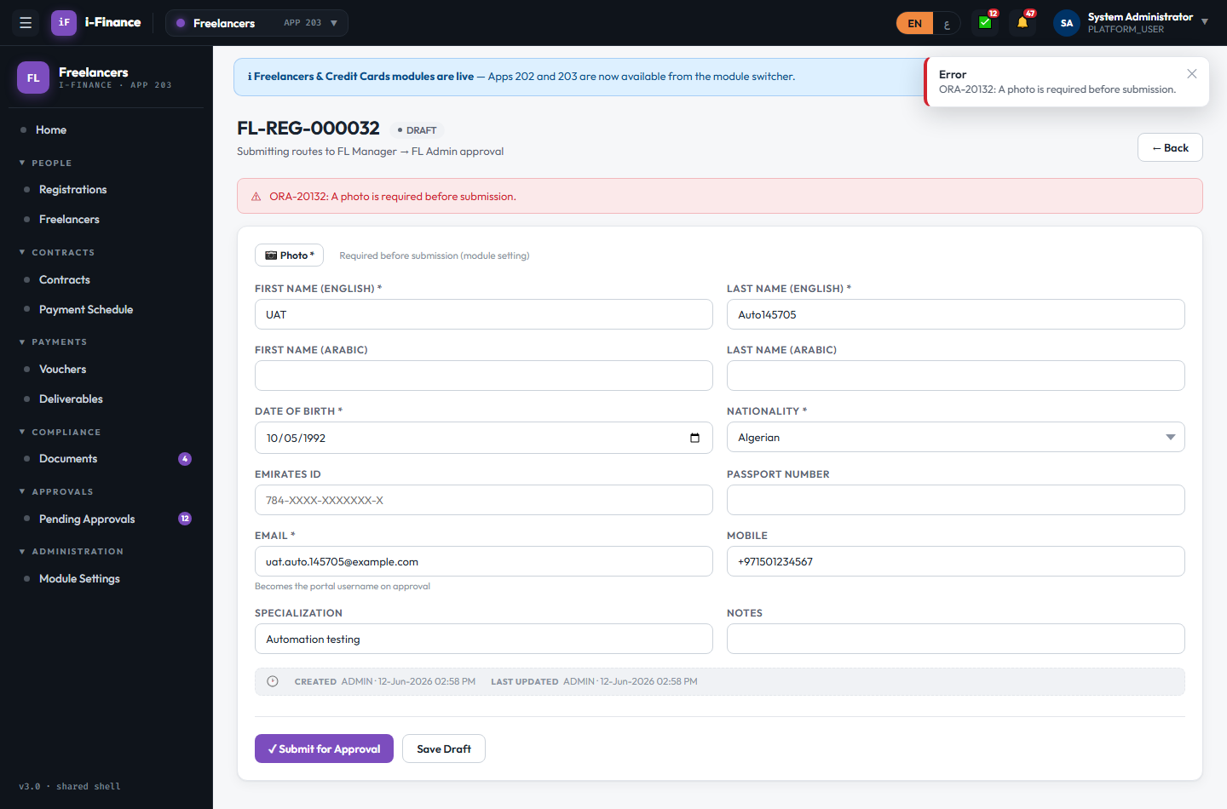
Evidence: FL-REG-03.png

FL-REG-04 — Send for approval
PASS · Submit · 4s
FL-REG-000032 submitted; status SUBMITTED; routed to the FL manager queue
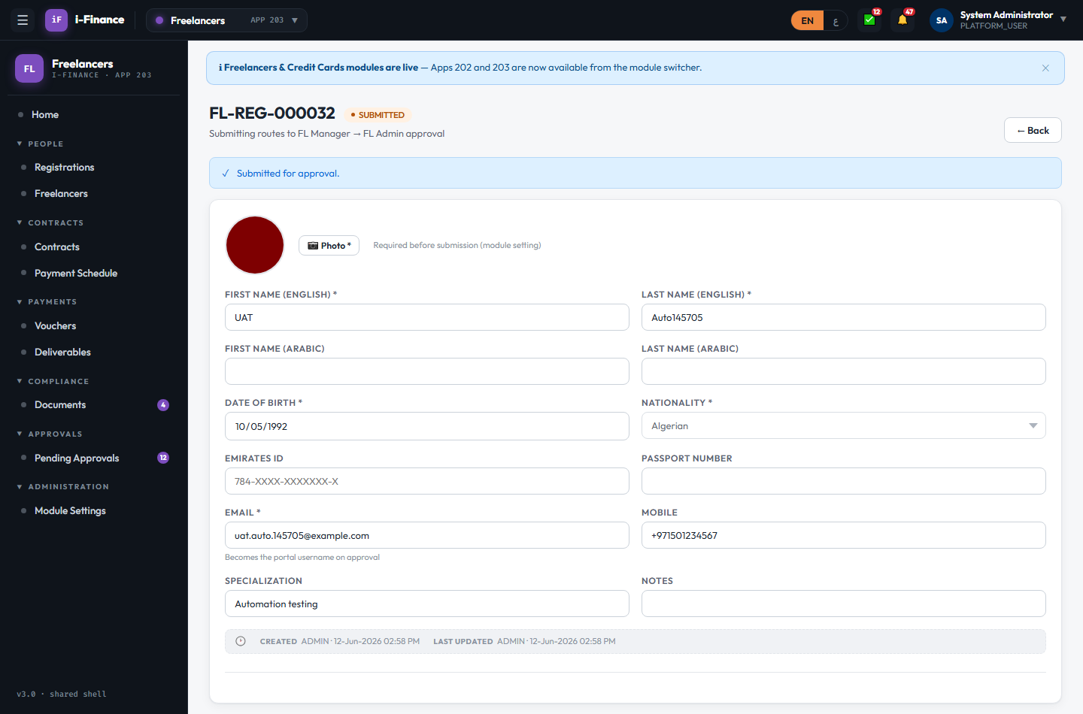
Evidence: FL-REG-04.png

FL-REG-05 — Approval creates the freelancer
PASS · Approve · 17s
Final approval auto-created freelancer FL-VND-000006 for FL-REG-000032
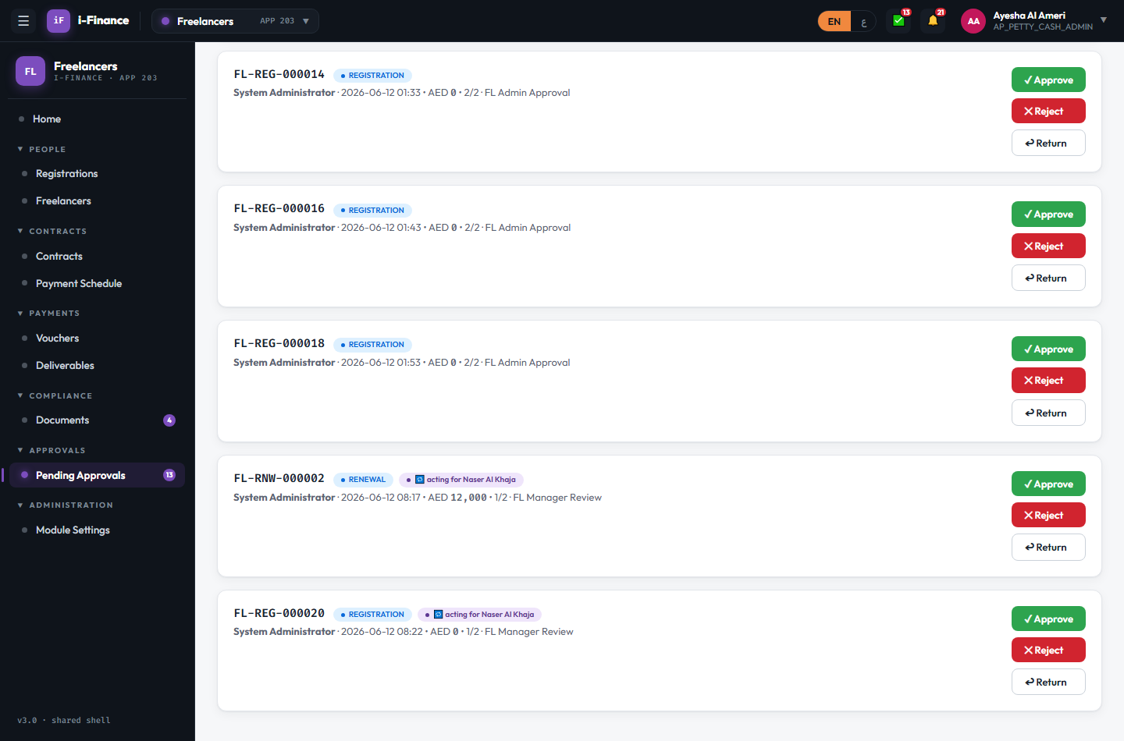
Evidence: FL-REG-05.png

Freelancers

FL-VND-01 — Directory
PASS · List · 3s
6 freelancers with vendor numbers, specialization and status
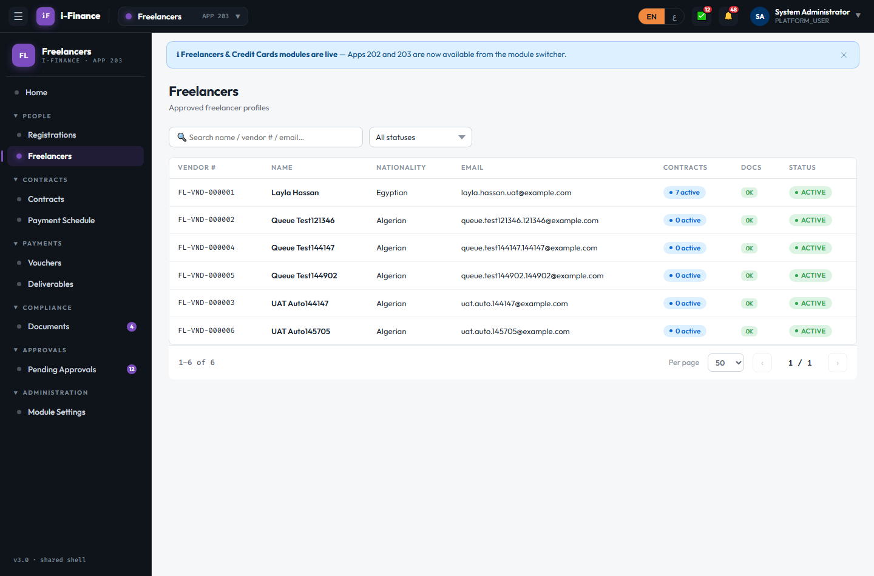
Evidence: FL-VND-01.png

FL-VND-02 — Tabs
PASS · Detail · 7s
Profile / Bank Accounts / Contracts / Documents tabs all load; audit info shown
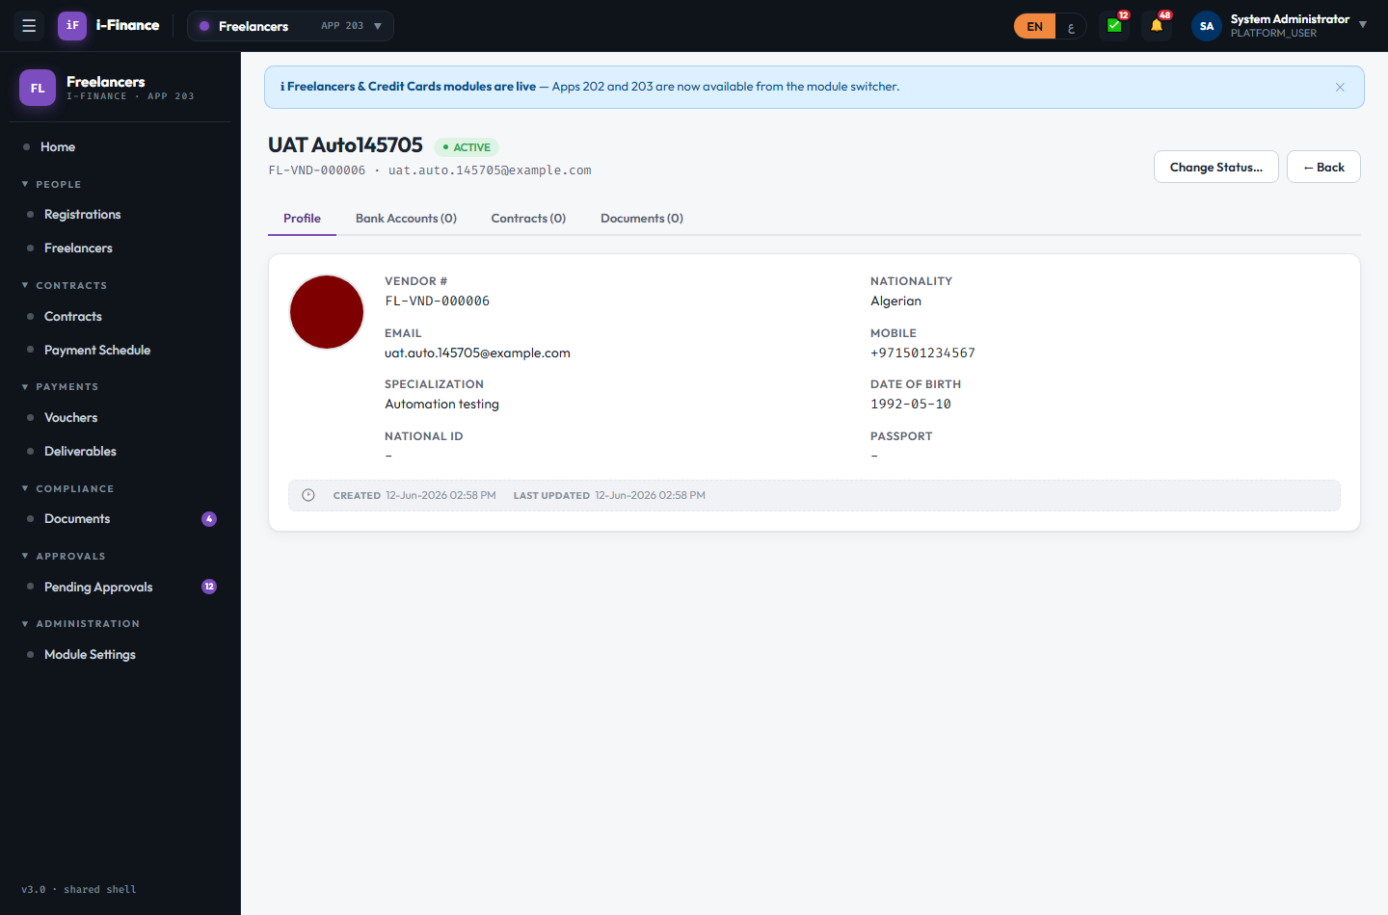
Evidence: FL-VND-02.png

FL-VND-03 — Add bank account
PASS · Bank · 8s
Bank account added (UAT Test Bank / AE07…) and listed with primary flag honoured
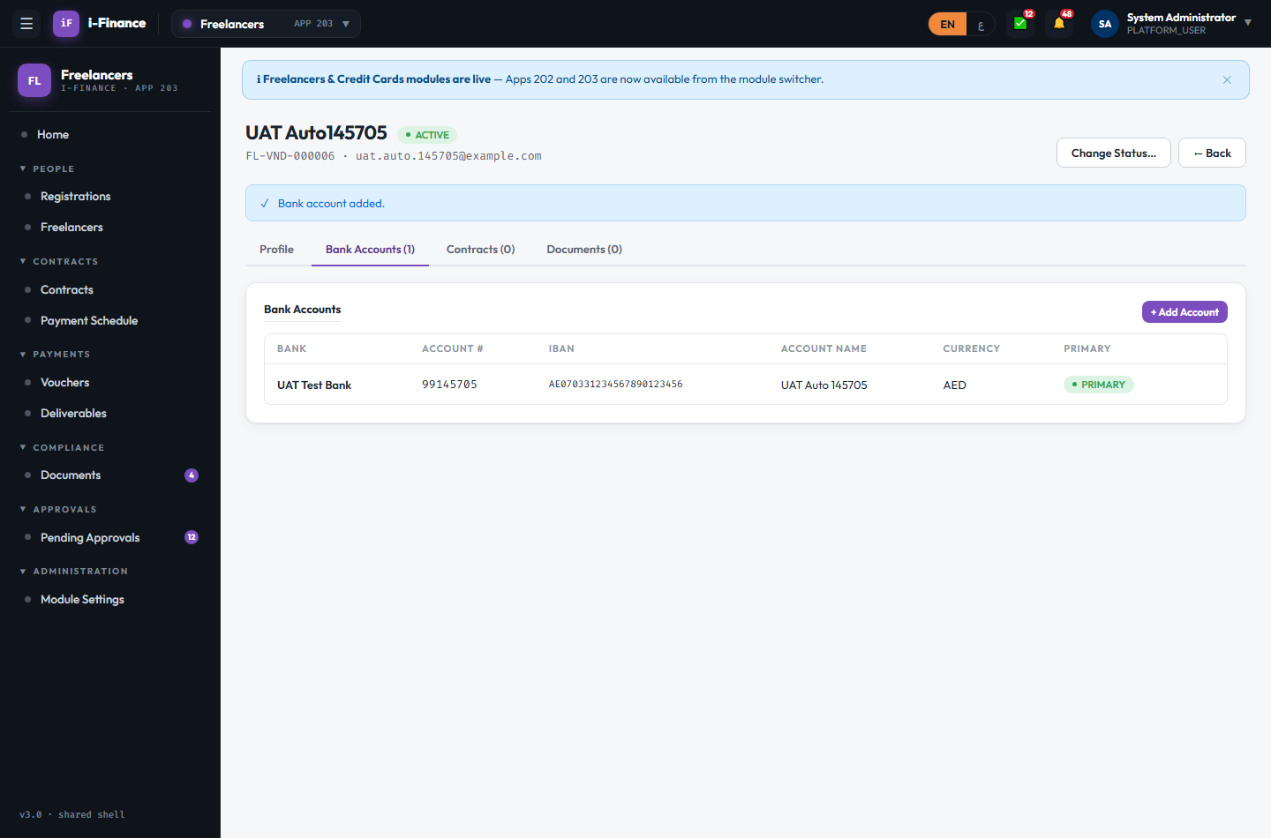
Evidence: FL-VND-03.png

FL-VND-04 — Change status
PASS · Status · 9s
ACTIVE → INACTIVE → ACTIVE; badge updated both ways
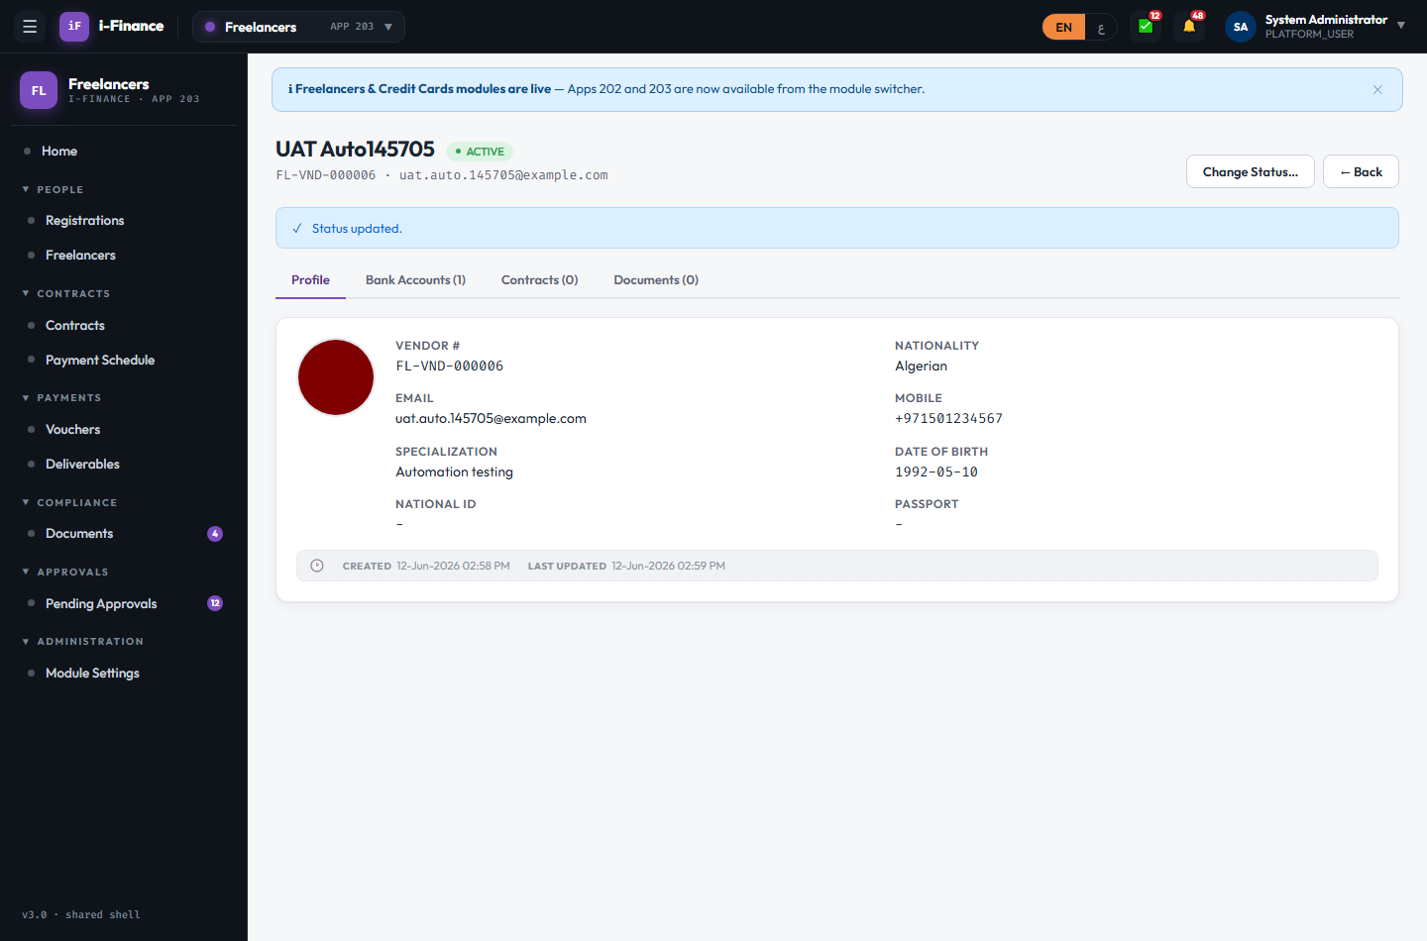
Evidence: FL-VND-04.png

FL-VND-05 — Add document with expiry
PASS · Documents · 7s
Document with +20d expiry saved; visible in the freelancer Documents tab
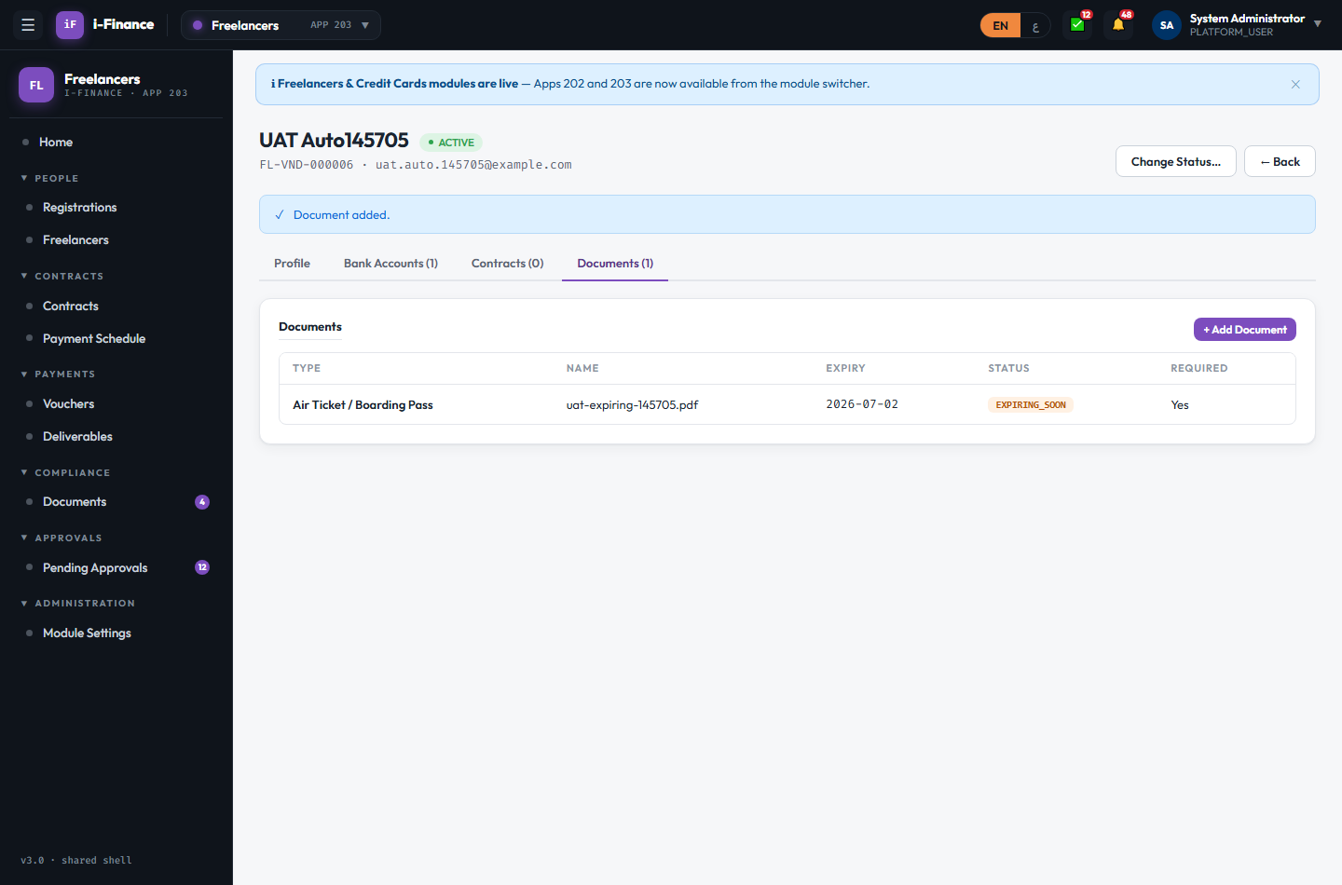
Evidence: FL-VND-05.png

Contracts

FL-CON-01 — Contracts with billing bar
PASS · List · 3s
9 contracts with totals, status and % billed progress bars
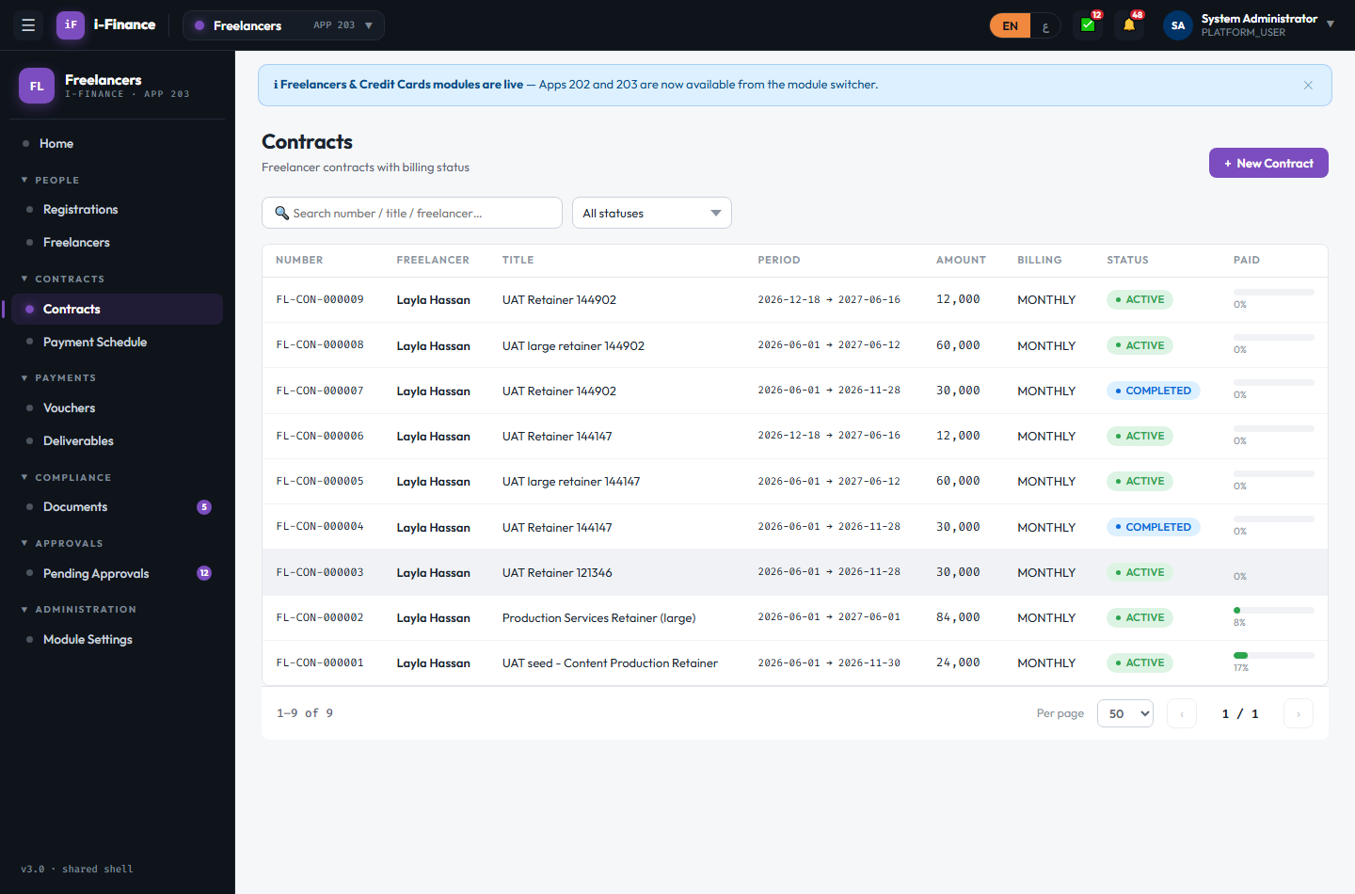
Evidence: FL-CON-01.png

FL-CON-02 — New contract draft
PASS · Create · 9s
Draft FL-CON-000010 saved (24,000 AED, MONTHLY, GL coding)
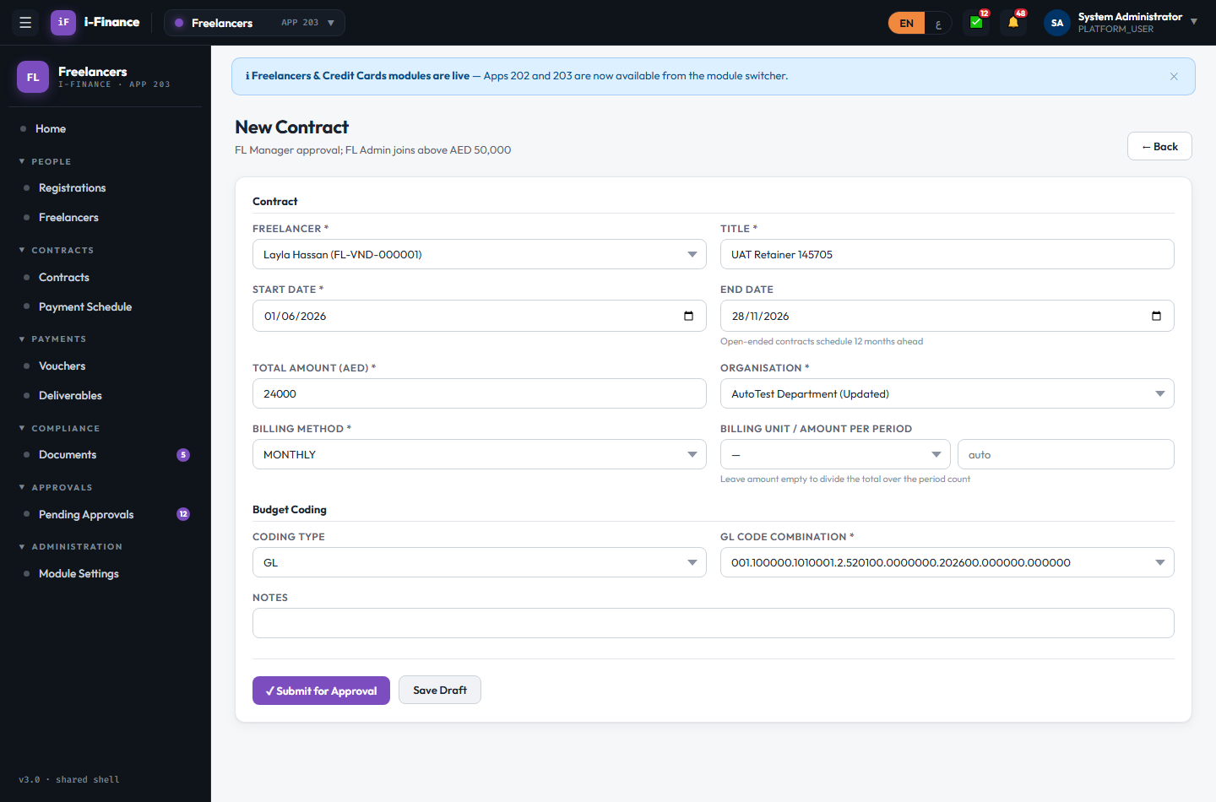
Evidence: FL-CON-02.png

FL-CON-03 — < 50k = 1 approval step
PASS · Submit small · 16s
24k contract ACTIVE after ONE manager approval; schedule auto-generated (6 rows)
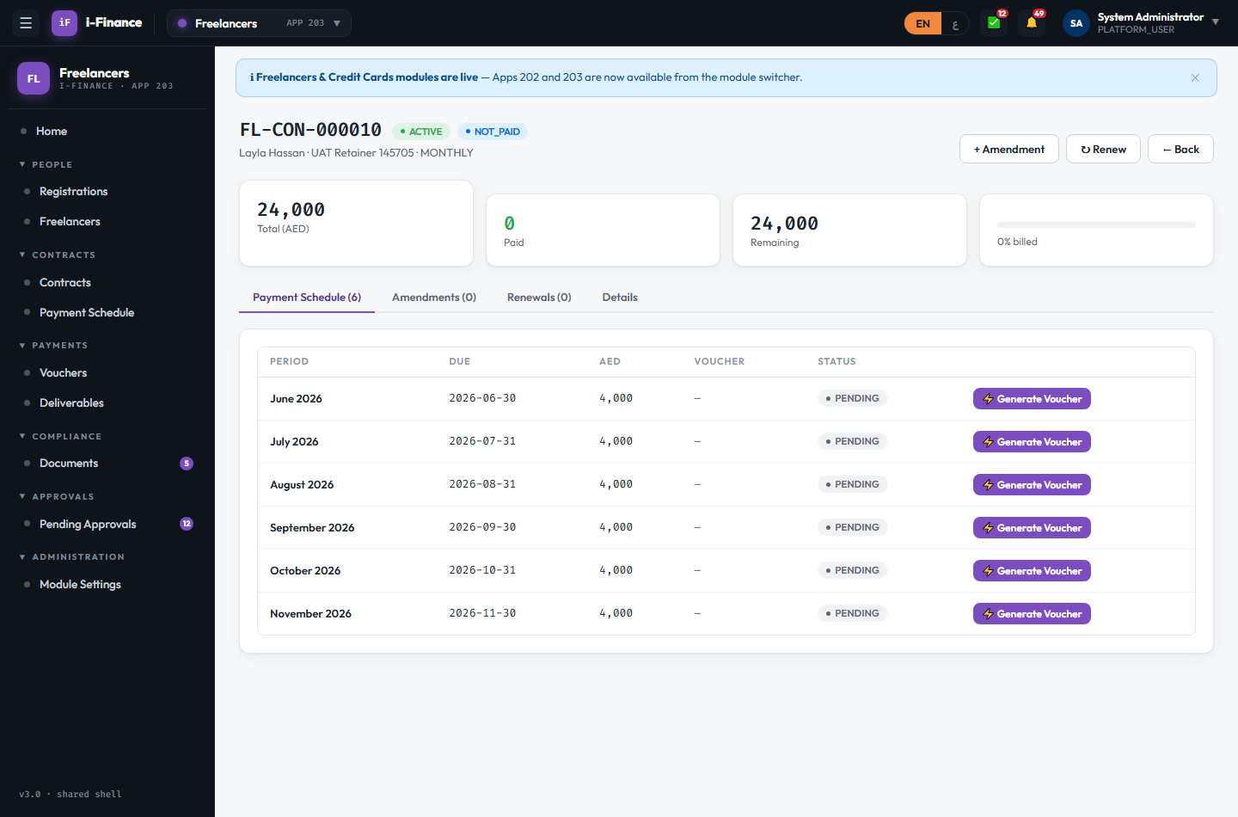
Evidence: FL-CON-03.png

FL-CON-04 — >= 50k = 2 approval steps
PASS · Submit large · 14s
FL-CON-000011 (>=50k) was pending at step 2/2 with FL Admin; ACTIVE only after the 2nd approval
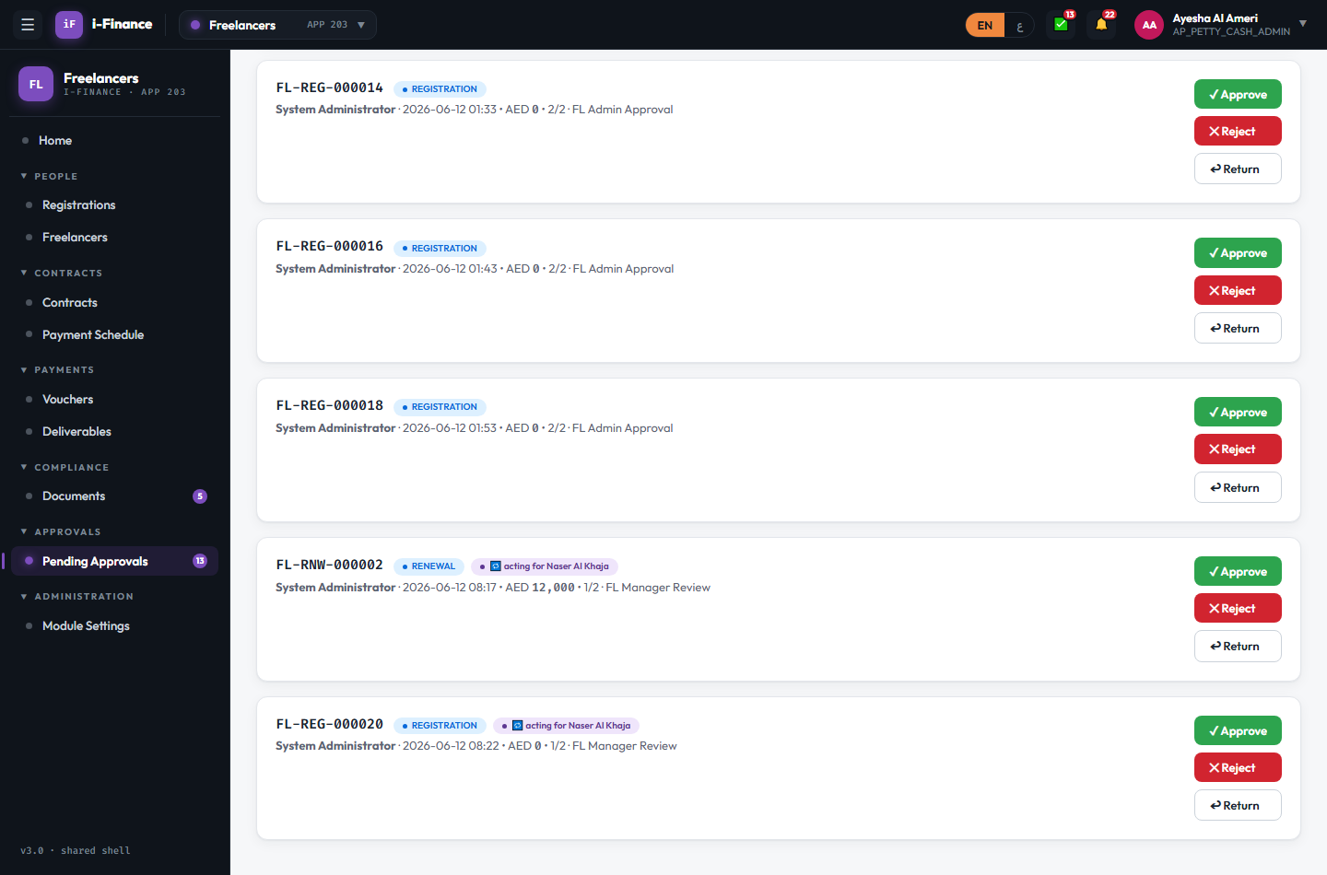
Evidence: FL-CON-04.png

FL-CON-05 — Schedule + tabs
PASS · Detail · 4s
Schedule (6 monthly rows) / Amendments / Renewals / Details tabs all render
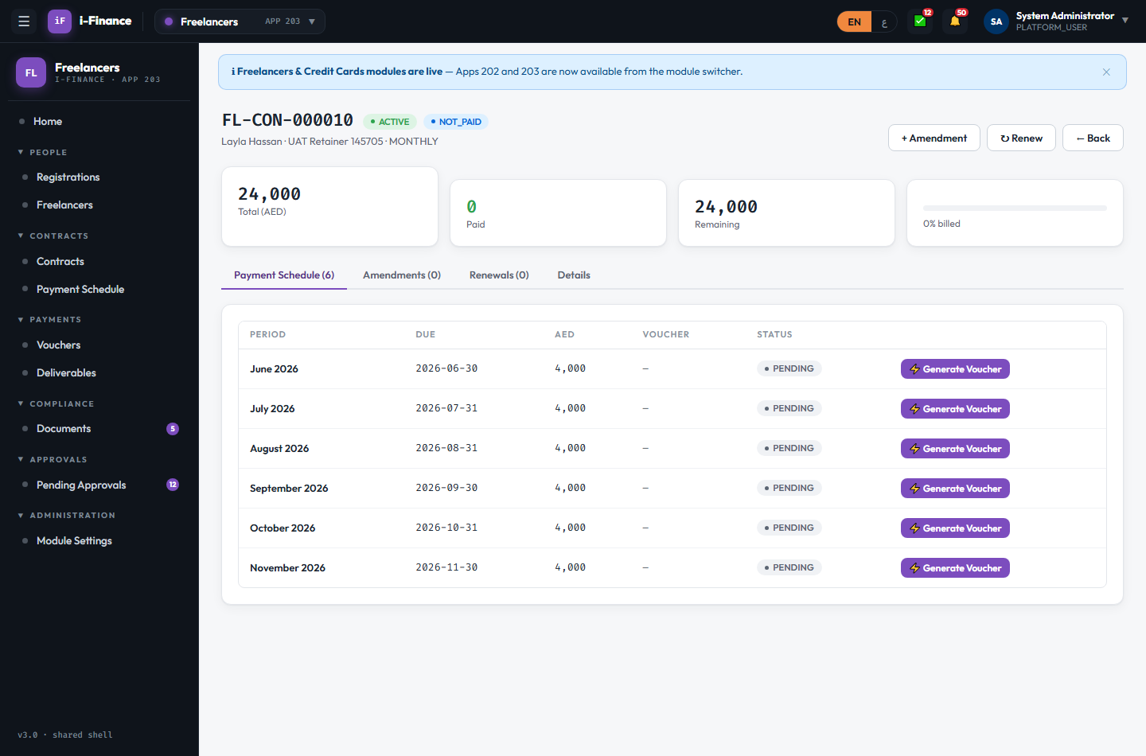
Evidence: FL-CON-05.png

FL-CON-06 — Amend amount/end date
PASS · Amendment · 20s
Amendment approved: total 24,000 → 30,000, version v2, schedule rebuilt
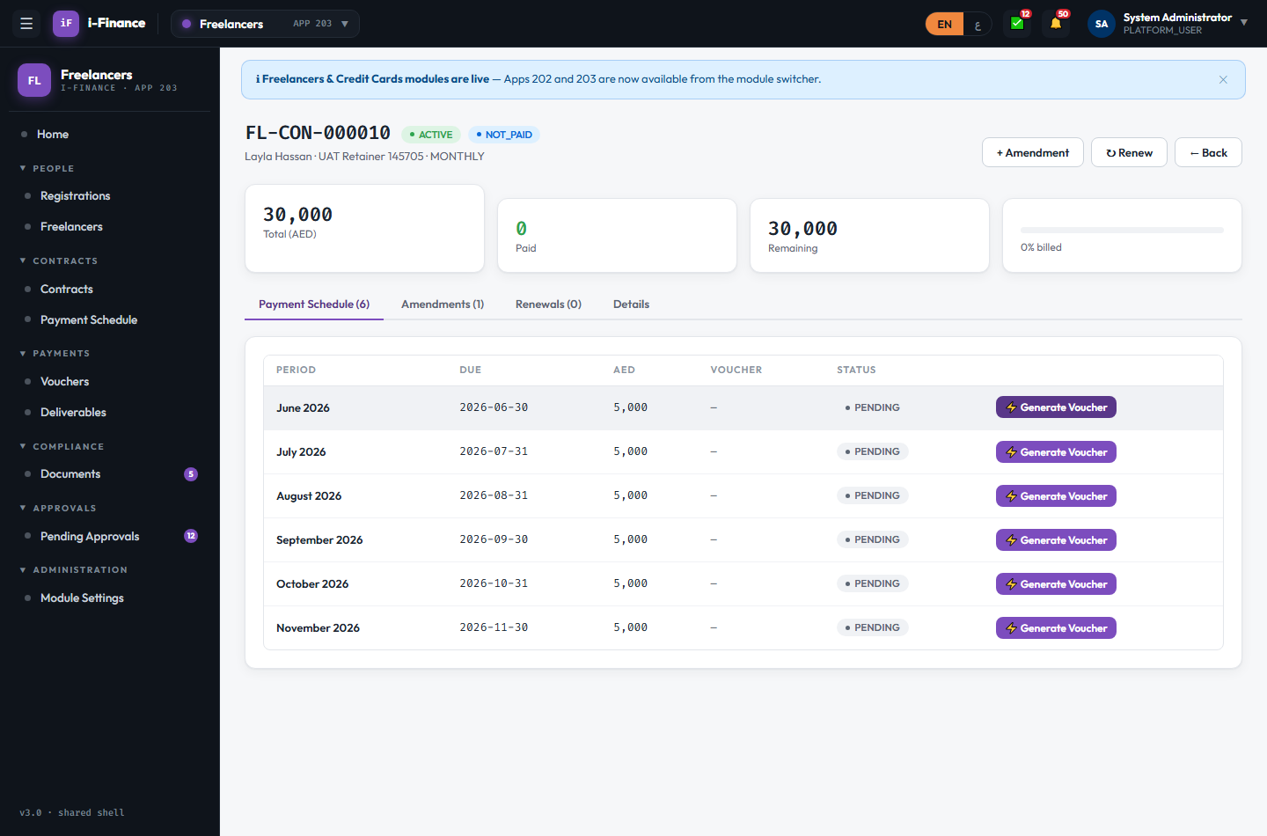
Evidence: FL-CON-06.png

FL-CON-07 — Renew a contract
PASS · Renewal · 21s
Renewal approved; a new contract row was created per the renewal terms
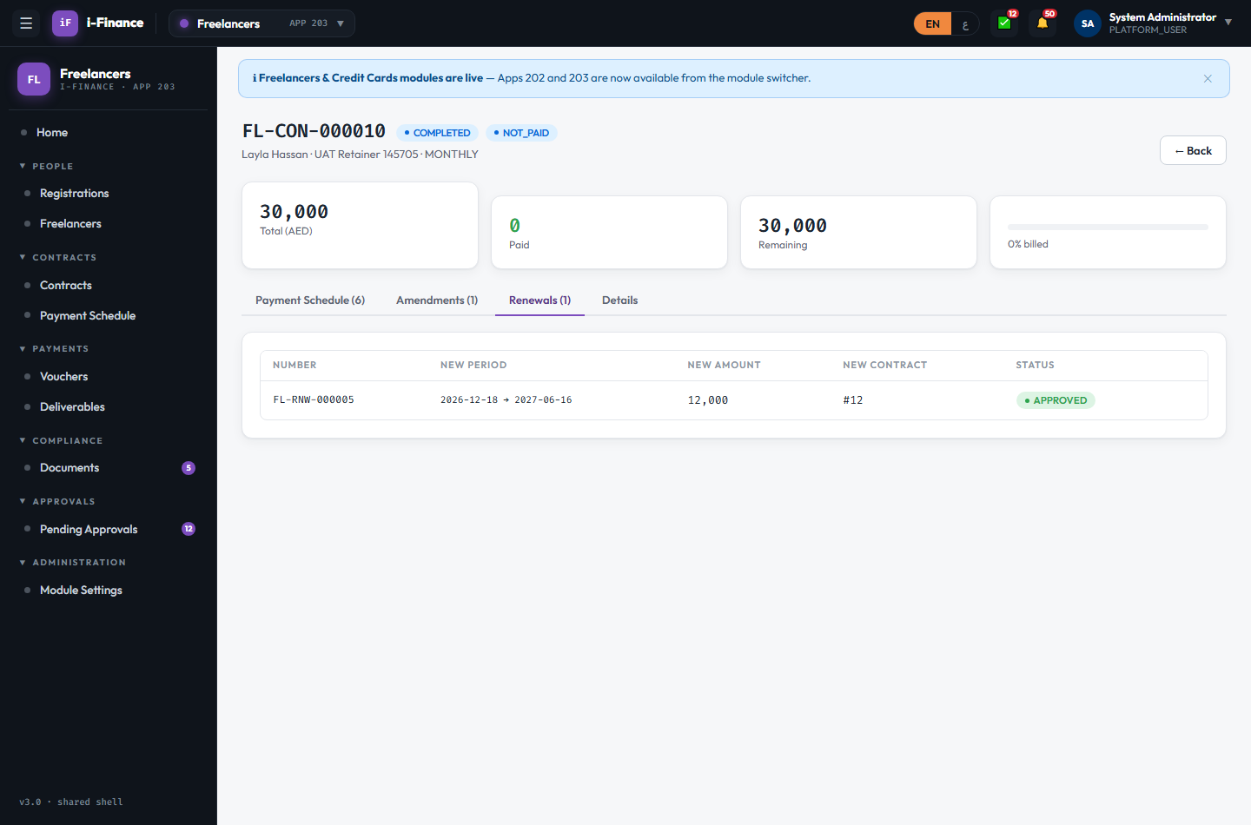
Evidence: FL-CON-07.png

Payments

FL-PAY-01 — Due worklist
PASS · Schedule · 3s
50 pending schedule rows across contracts with Generate Voucher actions
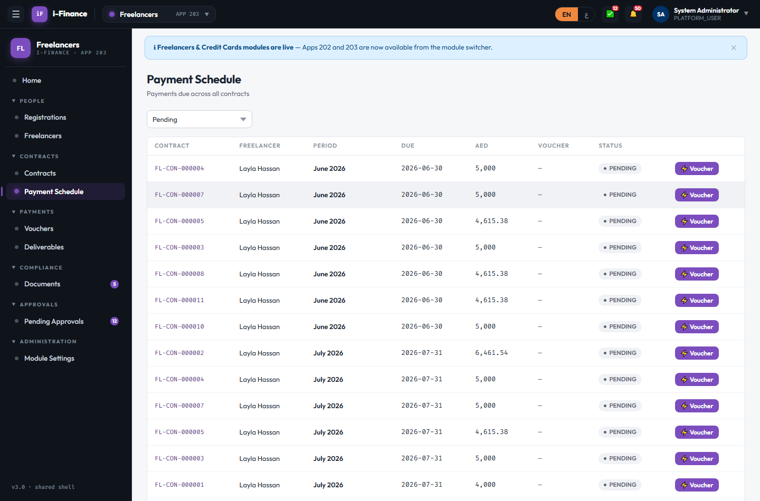
Evidence: FL-PAY-01.png

FL-PAY-02 — Generate from schedule
PASS · Voucher · 5s
FL-VCH-000004 created in DRAFT from the FL-CON-000004 schedule row
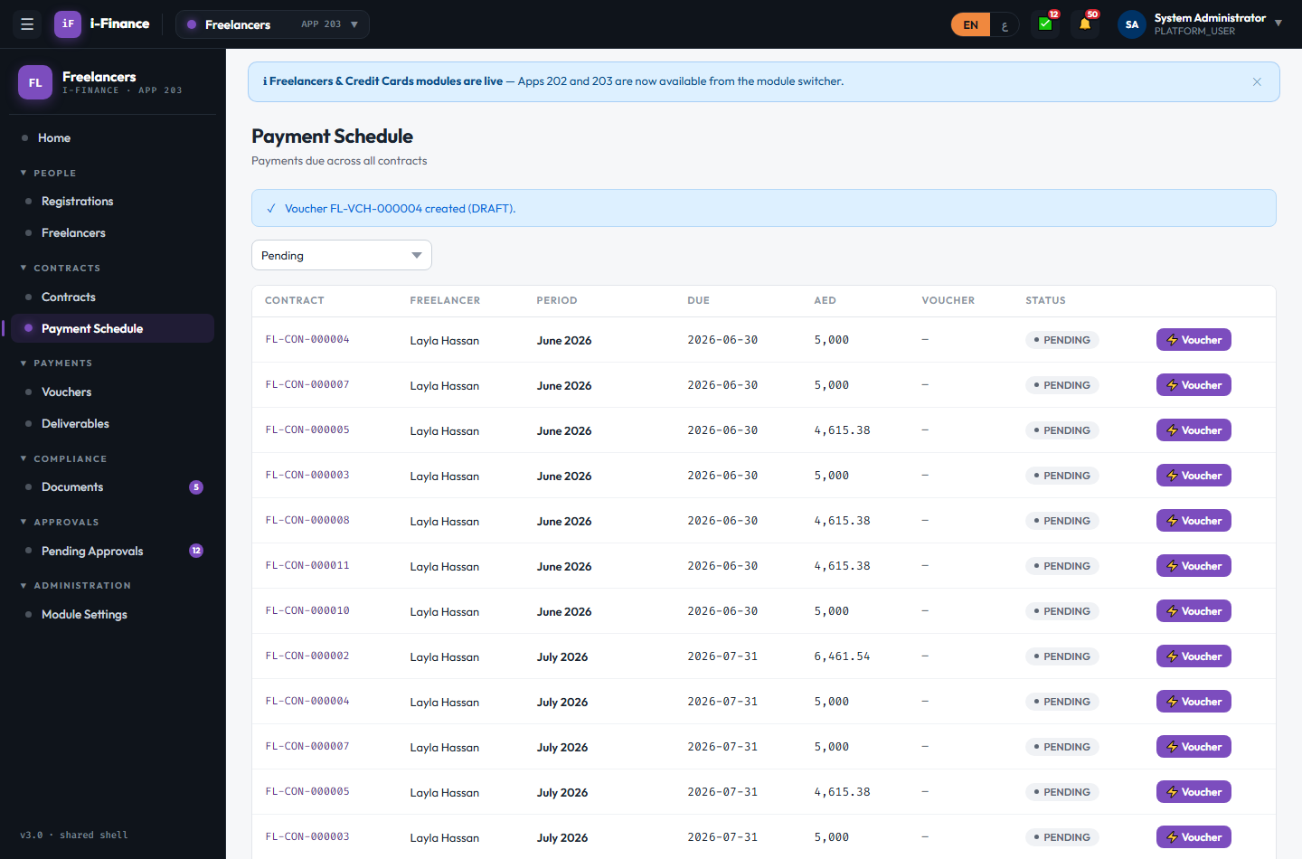
Evidence: FL-PAY-02.png

FL-PAY-03 — Invoice + submit
PASS · Voucher · 19s
FL-VCH-000004: invoice INV-UAT-145705 entered, submitted, approved
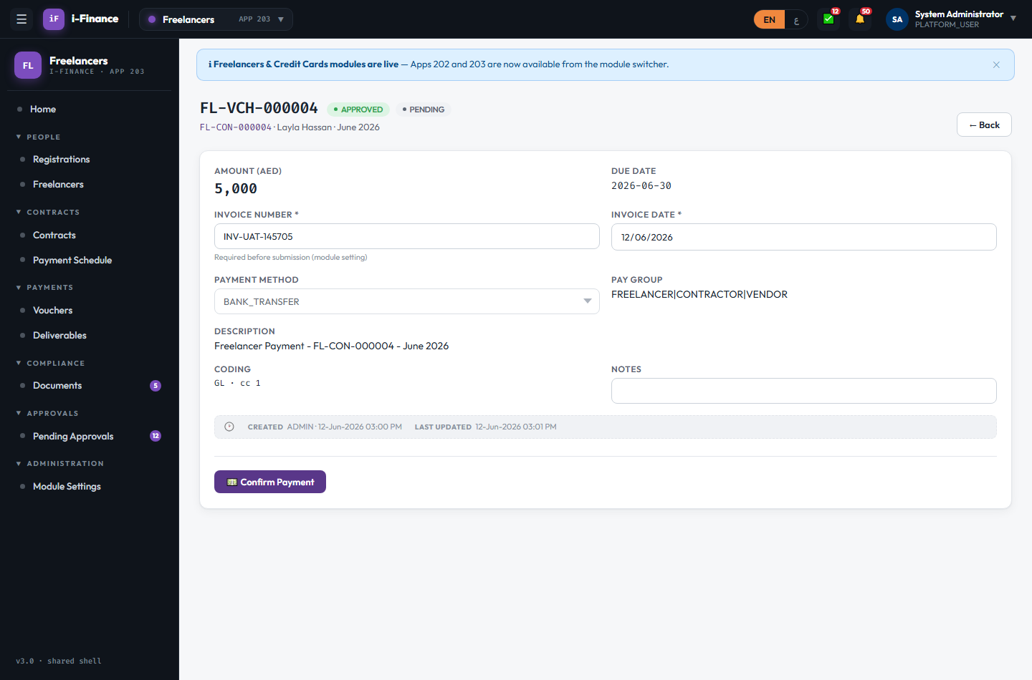
Evidence: FL-PAY-03.png

FL-PAY-04 — FL_ADMIN settles
PASS · Mark paid · 6s
FL Admin confirmed payment; FL-VCH-000004 payment status PAID; contract billed % updates
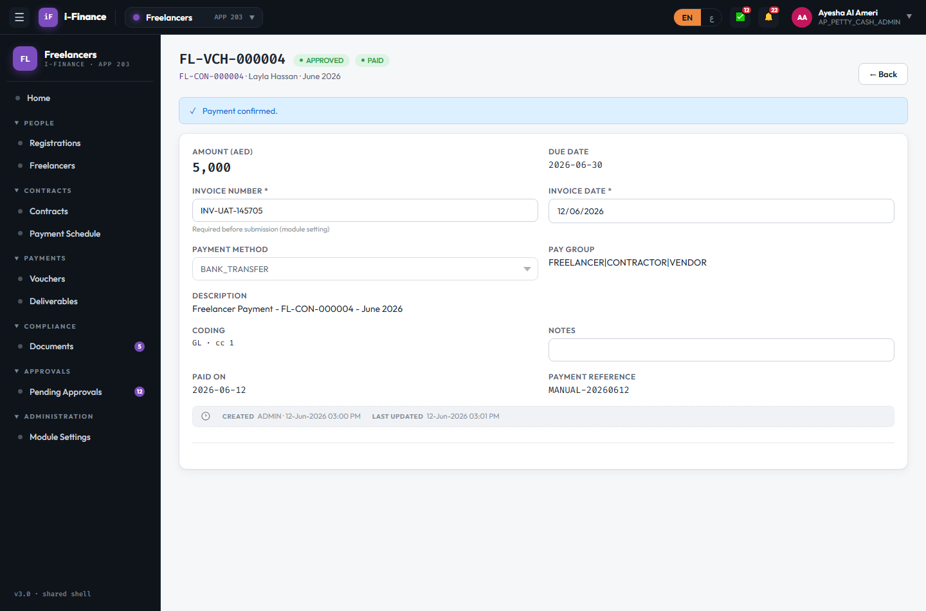
Evidence: FL-PAY-04.png

FL-PAY-05 — Accept / reject
PASS · Deliverables · 11s
Deliverable A accepted, B rejected with reason; states + reason visible
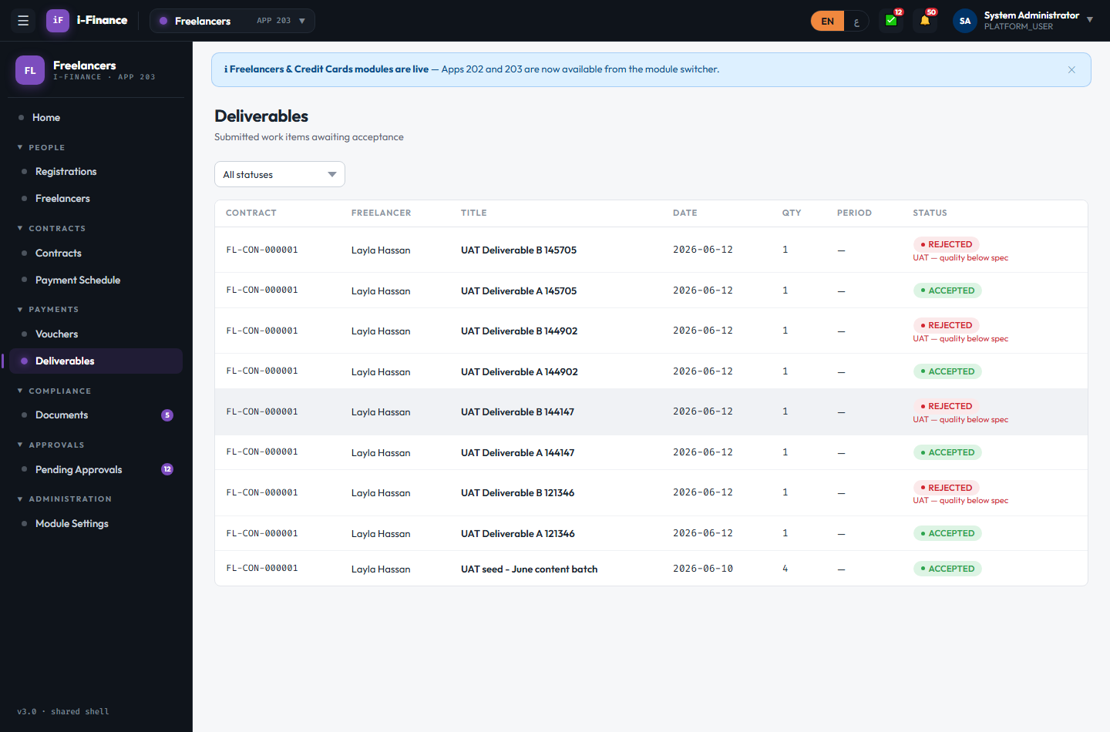
Evidence: FL-PAY-05.png

Compliance

FL-CMP-01 — Expiry filter + badge
PASS · Documents · 5s
EXPIRING_SOON filter → 5 rows with days-to-expiry; side-nav badge: 5
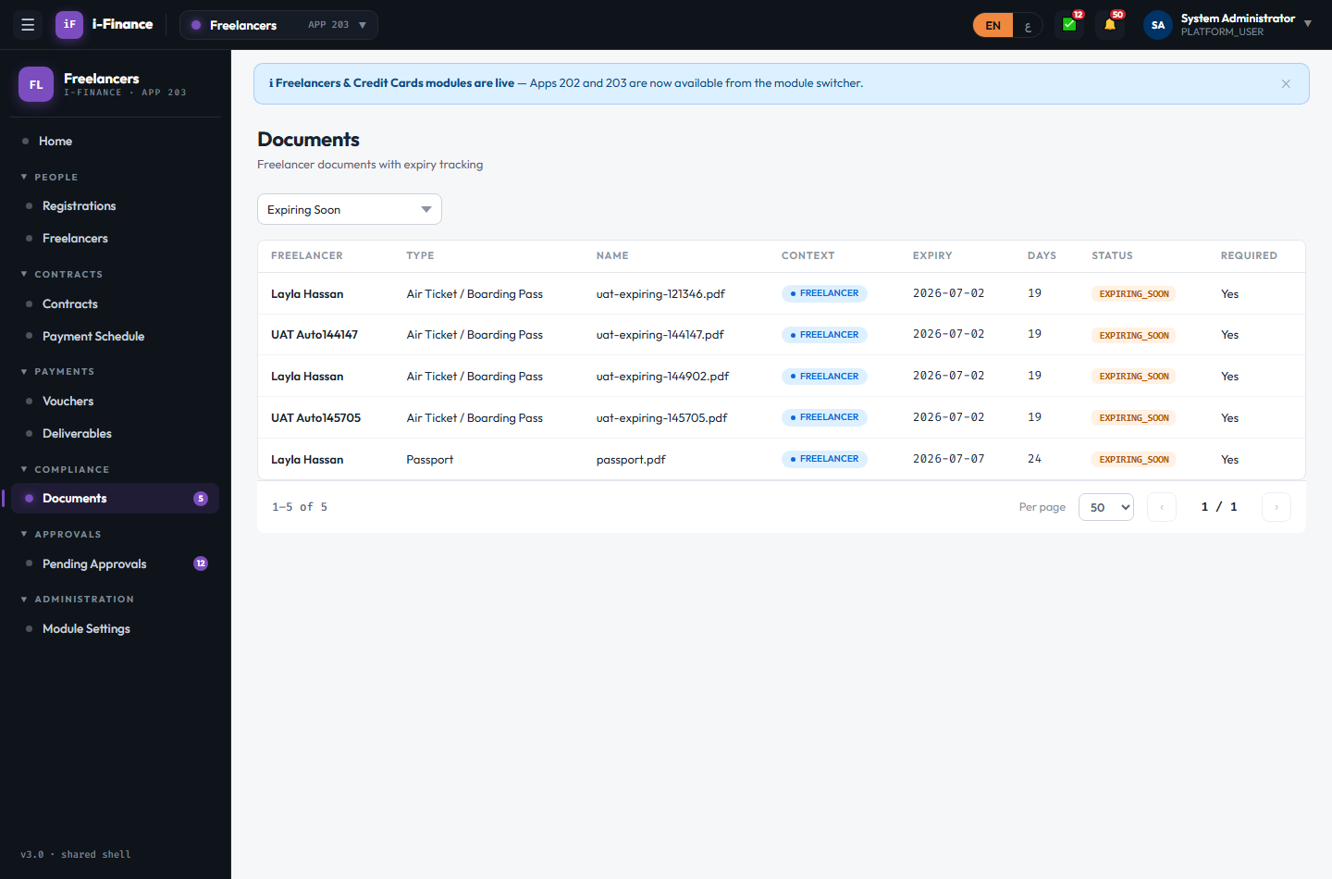
Evidence: FL-CMP-01.png

FL-CMP-02 — Document to freelancer
PARTIAL · Navigate · 7s
Row click opens the owning freelancer (lands on the Profile tab, not Documents — one extra click). Functional; flag if the direct-tab landing matters.
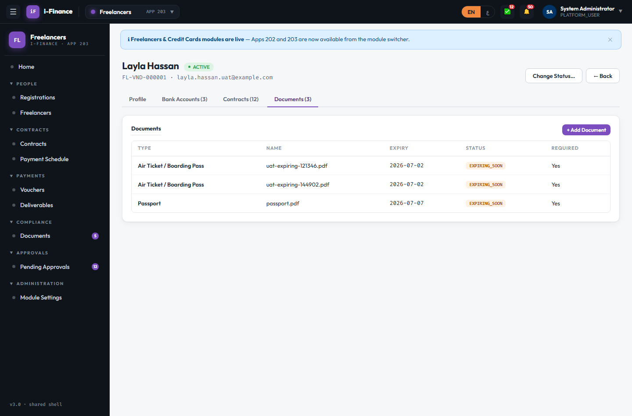
Evidence: FL-CMP-02.png

Approvals

FL-APR-01 — Pending list
PASS · Queue · 4s
8 items awaiting the FL manager (incl. FL-REG-000033); count shown: "8 item(s) awaiting your action"
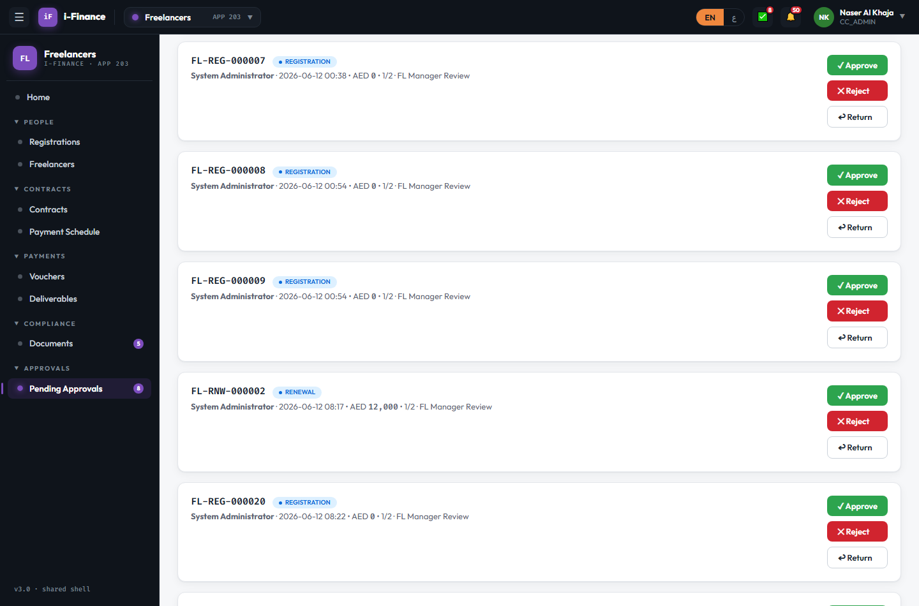
Evidence: FL-APR-01.png

FL-APR-02 — Approve needs a comment
PASS · Comment required · 6s
Empty comment blocked with "A comment is required."; item stayed in the queue
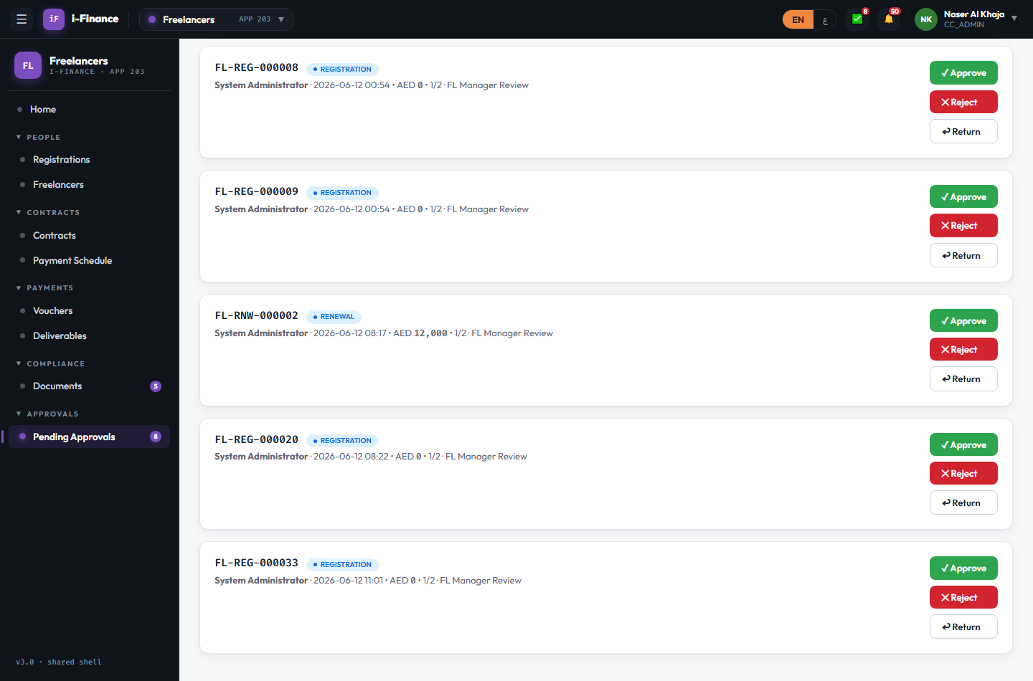
Evidence: FL-APR-02.png

FL-APR-03 — Negative paths
PASS · Reject / Return · 32s
FL-REG-000034 REJECTED, FL-REG-000035 RETURNED (editable again); both left the queue
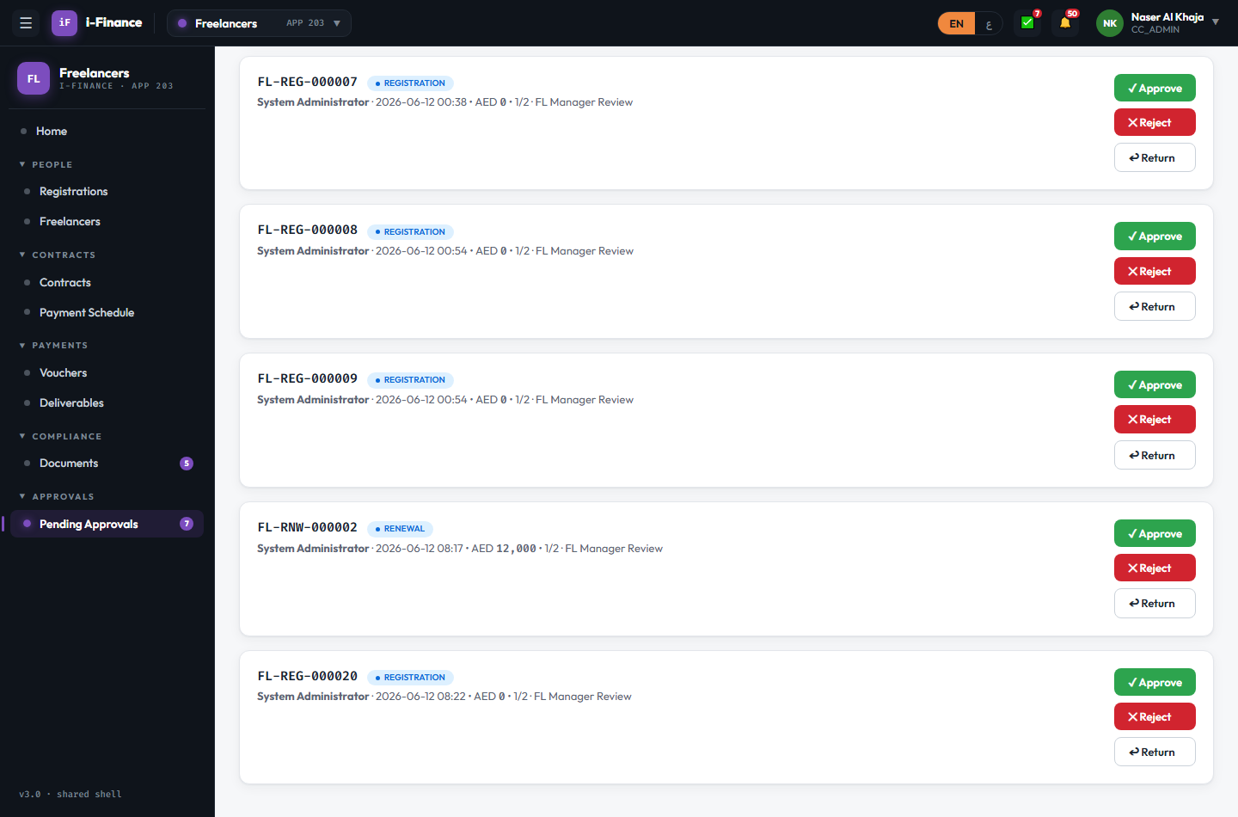
Evidence: FL-APR-03.png

Administration

FL-ADM-01 — FL settings
PASS · Module settings · 12s
DOC_EXPIRY_ALERT_DAYS 30 → 31 persisted across reload; restored to 30. Non-admins have no Module Settings nav (see FL-ACC-03)
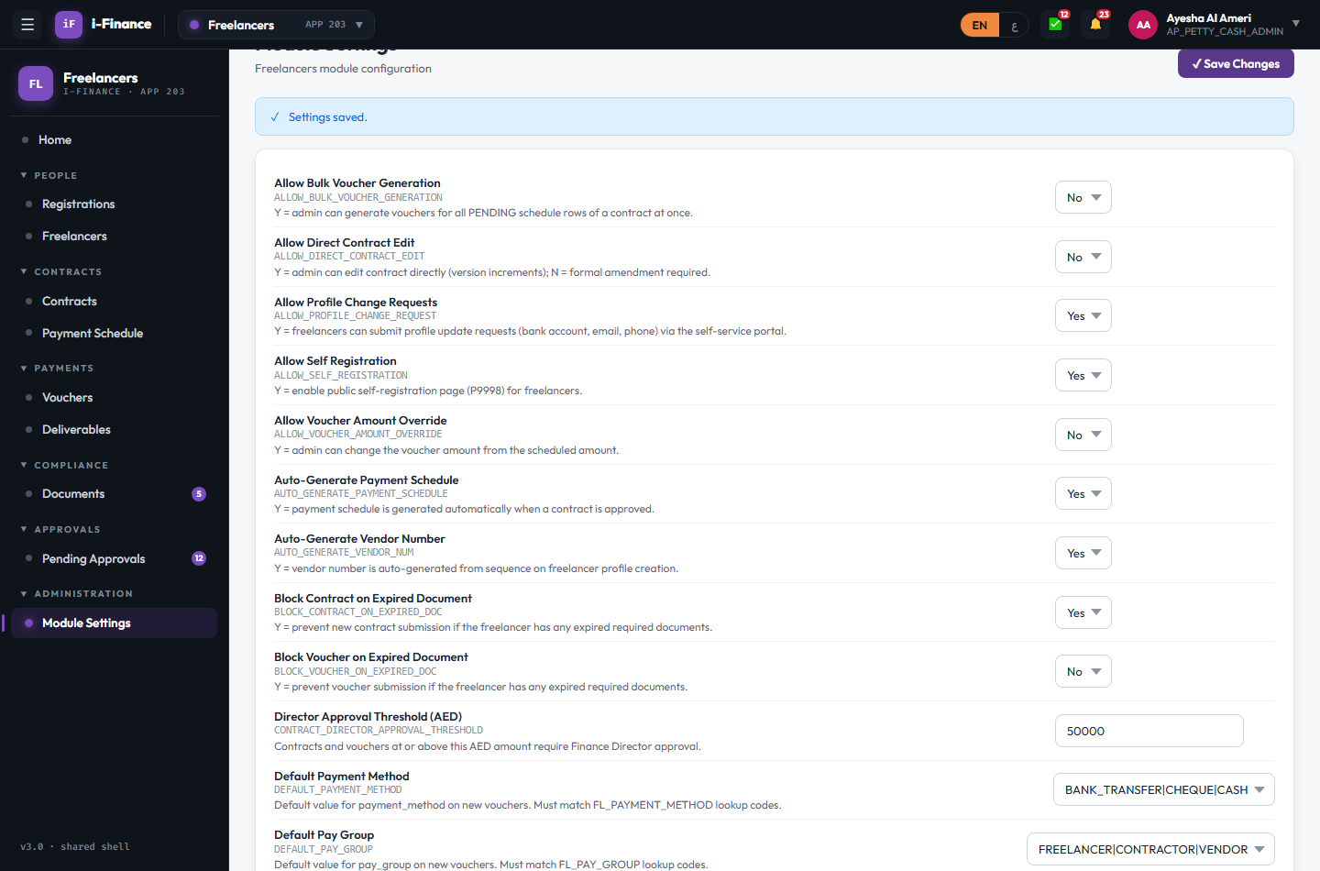
Evidence: FL-ADM-01.png

Shell & Language

FL-SHL-01 — Cross-module hop
PASS · Switcher · 8s
FL → Admin → FL with no re-login; FL listed live (no "soon" badge)
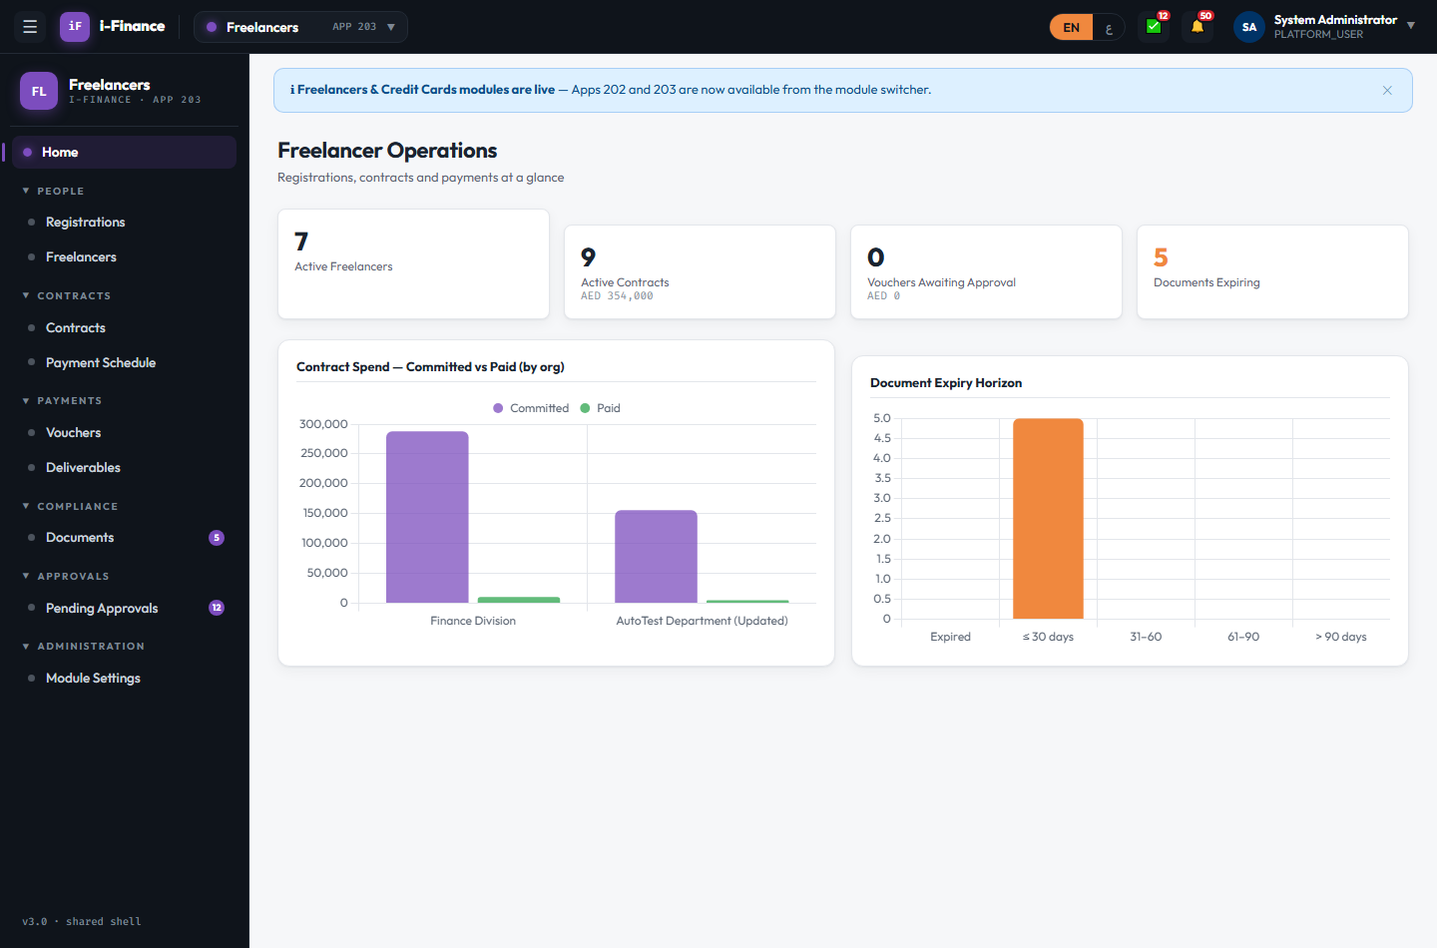
Evidence: FL-SHL-01.png

FL-SHL-02 — RTL pass
PASS · Arabic · 13s
RTL mirrored; AR labels with Latin digits; dashboard charts re-rendered (2); registrations + contract detail OK
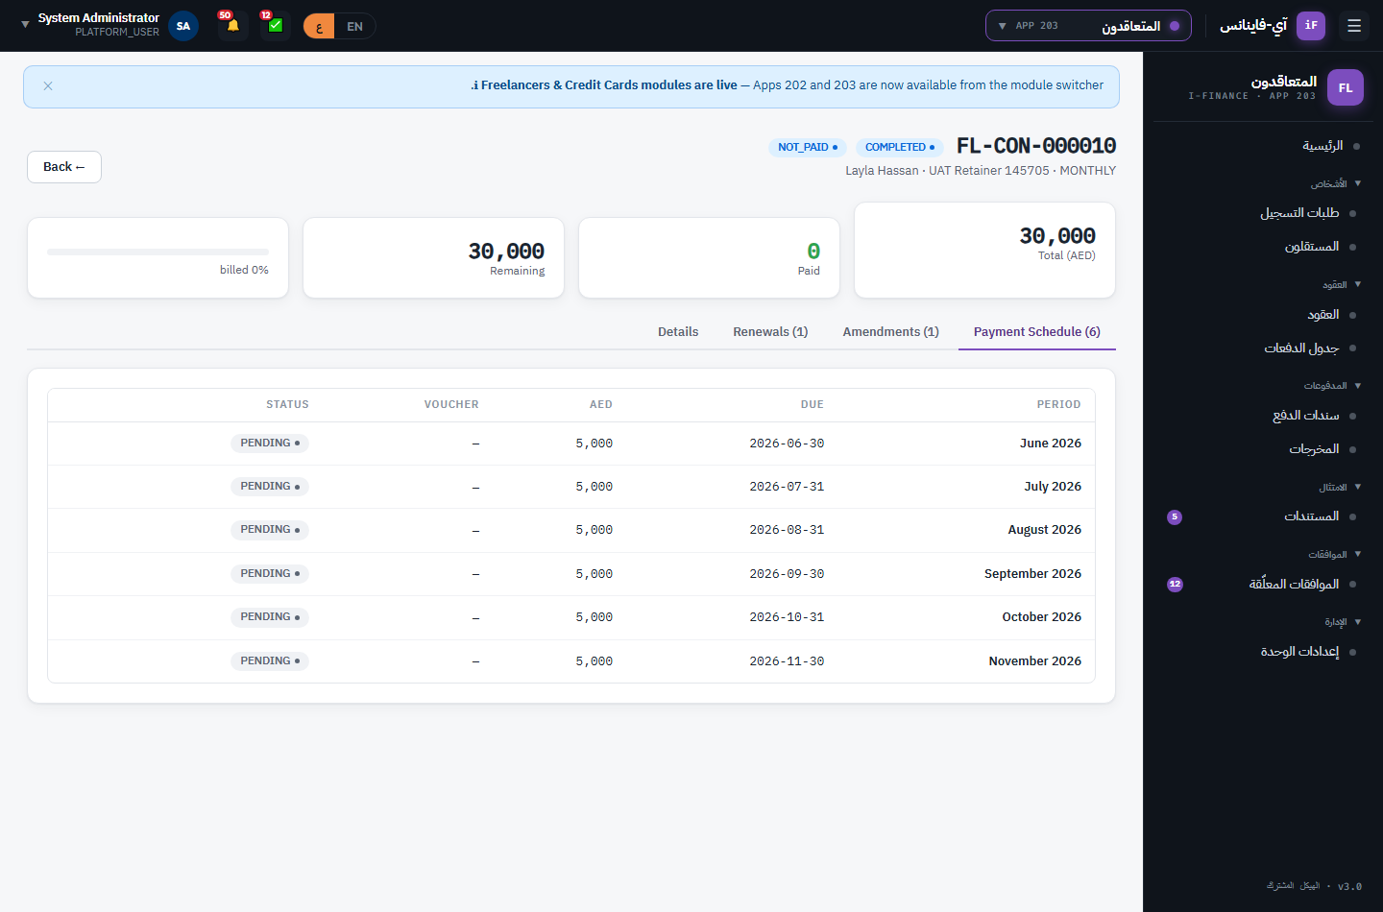
Evidence: FL-SHL-02.png

